Jennifer DeVore

23 March 2020

CIS 435

**Unit 4 Graded Exercise 1: Working with Views and Code Scripts**

1. **Write a CREATE VIEW statement that defines a view named InvoiceBasic that returns three columns: VendorName, InvoiceNumber, and InvoiceTotal. Then, write a SELECT statement that returns all of the columns in the view, sorted by VendorName, where the first letter of the vendor name is N, O, or P.**

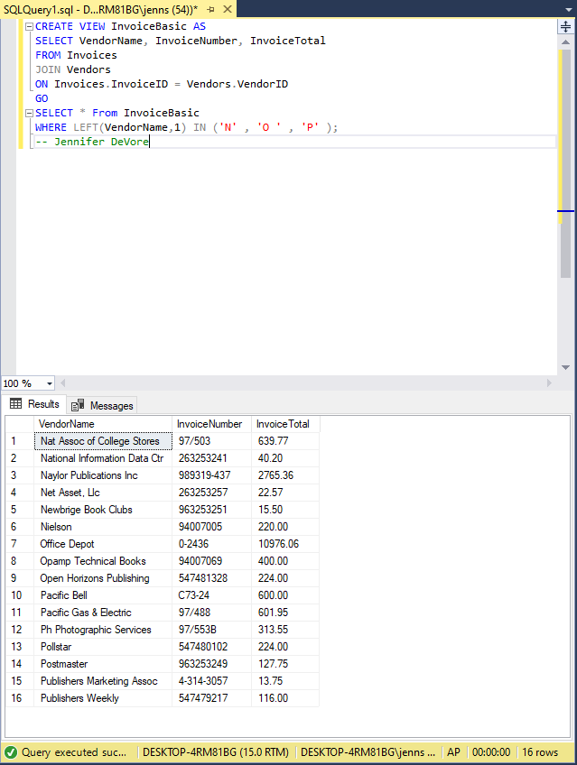

1. **Write a script that declares and sets a variable that’s equal to the total outstanding balance due. If that balance due is greater than $10,000.00, the script should return a result set consisting of VendorName, InvoiceNumber, InvoiceDueDate, and Balance for each invoice with a balance due, sorted with the oldest due date first. If the total outstanding balance due is less than $10,000.00, the script should return the message “Balance due is less than $10,000.00.”**

